Assignment - 1

Avinash Ravipudi

2022-09-23

#Installed and calling the ISLR packages

#install.packages("ISLR")  
#library(ISLR)

#Importing carseats Dataset to R programming

options(stringsAsFactors = FALSE)  
carseats <- read.csv("~/Desktop/Assignment -1 BA/carseats.csv")  
head(carseats,10)

## Sales CompPrice Income Advertising Population Price ShelveLoc Age Education  
## 1 9.50 138 73 11 276 120 Bad 42 17  
## 2 11.22 111 48 16 260 83 Good 65 10  
## 3 10.06 113 35 10 269 80 Medium 59 12  
## 4 7.40 117 100 4 466 97 Medium 55 14  
## 5 4.15 141 64 3 340 128 Bad 38 13  
## 6 10.81 124 113 13 501 72 Bad 78 16  
## 7 6.63 115 105 0 45 108 Medium 71 15  
## 8 11.85 136 81 15 425 120 Good 67 10  
## 9 6.54 132 110 0 108 124 Medium 76 10  
## 10 4.69 132 113 0 131 124 Medium 76 17  
## Urban US  
## 1 Yes Yes  
## 2 Yes Yes  
## 3 Yes Yes  
## 4 Yes Yes  
## 5 Yes No  
## 6 No Yes  
## 7 Yes No  
## 8 Yes Yes  
## 9 No No  
## 10 No Yes

#calling ISLR LIbrary and printing summary of carseats data set

library(ISLR)  
summary(carseats)

## Sales CompPrice Income Advertising   
## Min. : 0.000 Min. : 77 Min. : 21.00 Min. : 0.000   
## 1st Qu.: 5.390 1st Qu.:115 1st Qu.: 42.75 1st Qu.: 0.000   
## Median : 7.490 Median :125 Median : 69.00 Median : 5.000   
## Mean : 7.496 Mean :125 Mean : 68.66 Mean : 6.635   
## 3rd Qu.: 9.320 3rd Qu.:135 3rd Qu.: 91.00 3rd Qu.:12.000   
## Max. :16.270 Max. :175 Max. :120.00 Max. :29.000   
## Population Price ShelveLoc Age   
## Min. : 10.0 Min. : 24.0 Length:400 Min. :25.00   
## 1st Qu.:139.0 1st Qu.:100.0 Class :character 1st Qu.:39.75   
## Median :272.0 Median :117.0 Mode :character Median :54.50   
## Mean :264.8 Mean :115.8 Mean :53.32   
## 3rd Qu.:398.5 3rd Qu.:131.0 3rd Qu.:66.00   
## Max. :509.0 Max. :191.0 Max. :80.00   
## Education Urban US   
## Min. :10.0 Length:400 Length:400   
## 1st Qu.:12.0 Class :character Class :character   
## Median :14.0 Mode :character Mode :character   
## Mean :13.9   
## 3rd Qu.:16.0   
## Max. :18.0

#Observations (Rows) contains in this dataset

nrow(carseats)

## [1] 400

#maximum value of the advertising attribute

lm.fit=lm(Sales~Advertising+Price,data=carseats)  
max(carseats$Advertising)

## [1] 29

#IQR for Price attribute.

IQR(carseats$Price)

## [1] 31

#plot aganist sales & Price

Sales<- carseats$Sales  
Price<- carseats$Price  
plot(Sales,Price)

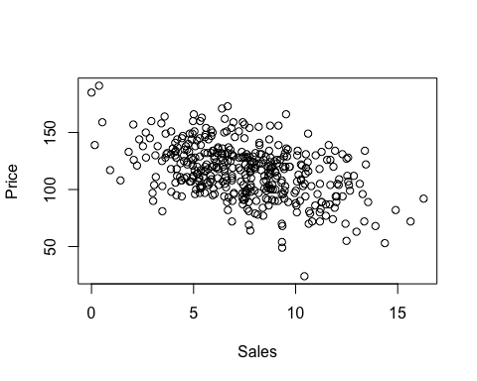

#correlation of the two attributes.

#install.packages("ggpubr")  
library("ggpubr")

## Loading required package: ggplot2

print(cor(carseats$Sales,carseats$Price))

## [1] -0.4449507

#In an inverse relationship (a negative correlation), one variable increases while the other decreases.